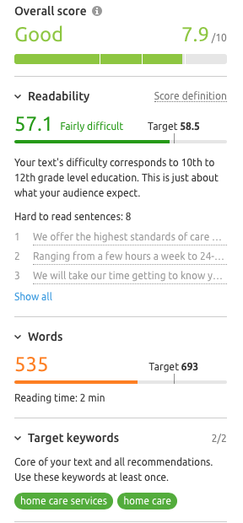 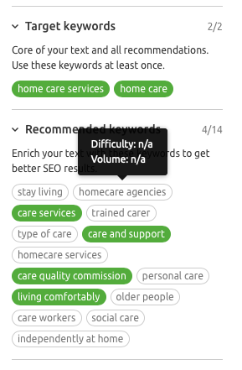

*Home Care Services (4,400 – 62%)*

*Home care (3,600 – 58%)*

**HOME CARE SERVICES**

HFHC Healthcare offers a wide range of healthcare and support services in your own home. Ranging from a few hours a week to 24-hour care, to provide the support required for you or a loved one to remain independent and maintain a safe, active and fulfilling life regardless of physical or mental disability or complex care needs.

We can offer a full range of home care services, regardless of how complex your needs may be. This can range from Mental Health or Learning Disability Support to Dementia or Palliative Care. We can meet the needs of those who though illness or injury need a little extra support to maintain their independence.

Every person who we support has their own bespoke home care package tailored to their individual needs. We know that every person if unique and that a one-size-fits-all approach simply would not work. As such, all of our care and support packages are created from scratch with you or your loved one at the centre of all we do.

We understand that needs change, so we are highly responsive, changing with you as your needs change to ensure we always provide you with the most effective and suitable care and support for your unique needs.

We offer the highest standards of care and are regulated by the Care Quality Commission, giving you peace of mind that you or your loved one will always be our number one priority and will be treated with compassion and dignity at all times.

We will take our time getting to know you so that we know the ‘little things’, like how you like your tea, which newspaper you read, whether you like to sit indoors or in the garden when it is sunny. Our caring staff will become your friends as they support you to maintain an active life, helping you with shopping, to attend a community event or simply offering help with a cross word.

We only recruit and train reliable, flexible and caring professionals, who all embrace our values and ethos. We invest heavily in comprehensive training and staff development in order to provide exceptional care and support.

You can have total confidence in our compliance process, which includes gaining references and a ten-year checkable work history. We also provide training, an occupational health assessment and enhanced DBS checks as part of our rigorous candidate registration process.

If you would like to find out more, please take a look at the services we offer in more detail.

**WHAT IS HOME CARE**

Home care offers care and support in your own home as an alternative to hospital, hospices, care homes and nursing homes. It allows you to live comfortably and independently regardless of medical or mental health needs.

It includes physical support, mental support and companionship for people needling a little extra help, from a few hours a week to 24 hour care. Home Care can offer peace of mind to relatives that their loved one is being cared for and supported at times when they are not able to. It can also provide another pair of hands to share the care and offer support during end of life care.